Assignment Day4

1. Creating two Machines: Master and Worker Node.

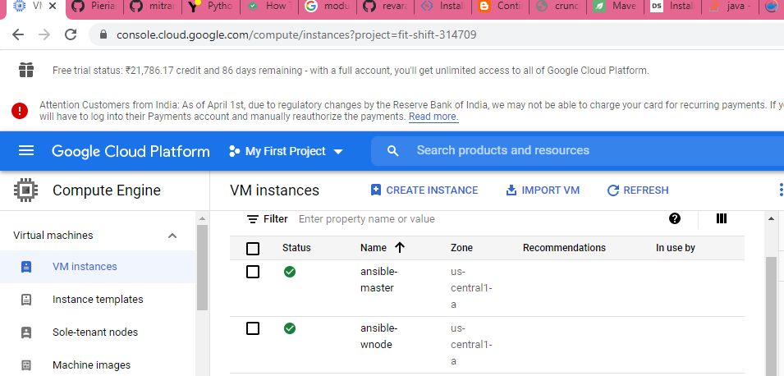

1. In Master Node:generating the keys using keygen.

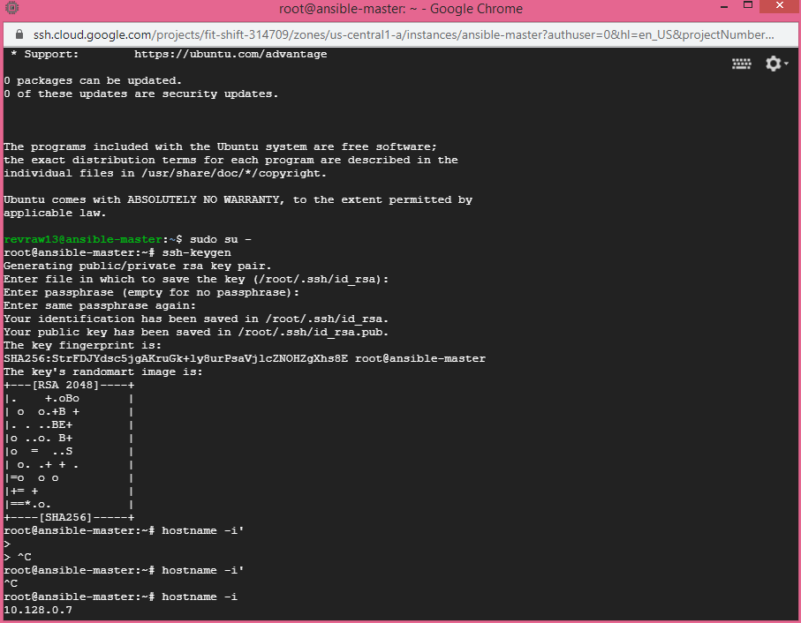

1. In Worker Node: Changed the sshd_config file, restarted the services and set the user password for first time connection from master.

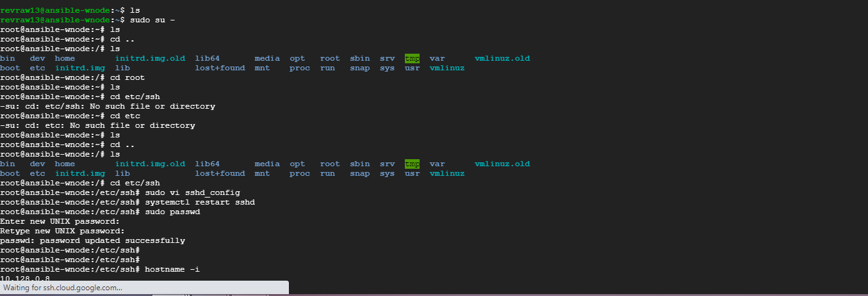

1. Connected to worker node from master without password.

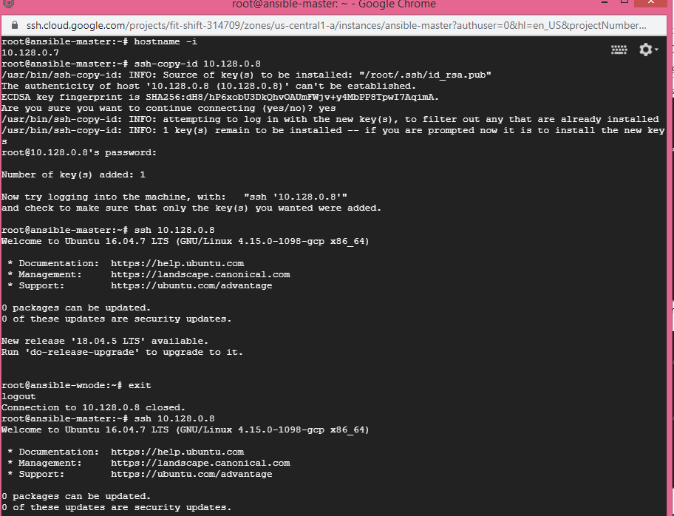

1. Installed Ansible

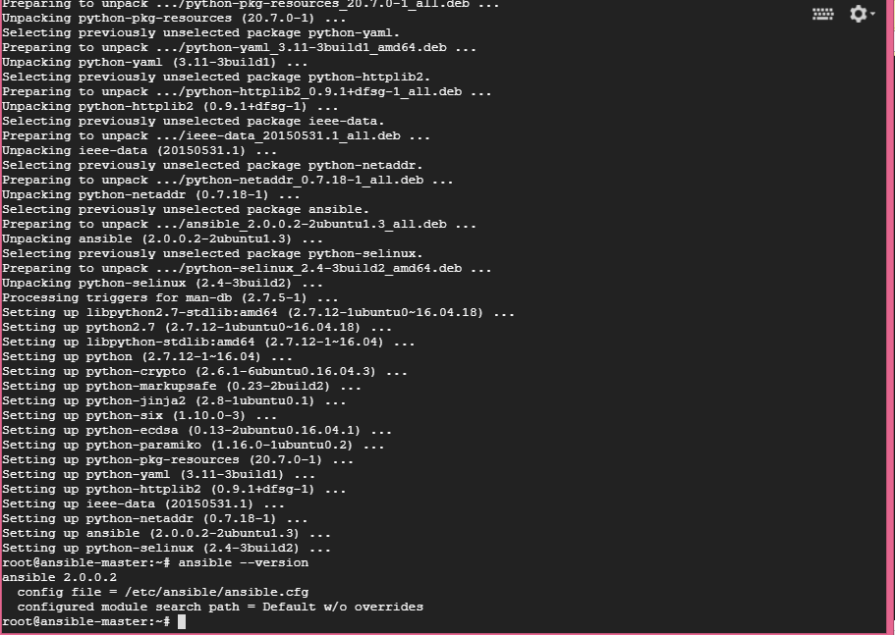

1. Checked the connection.

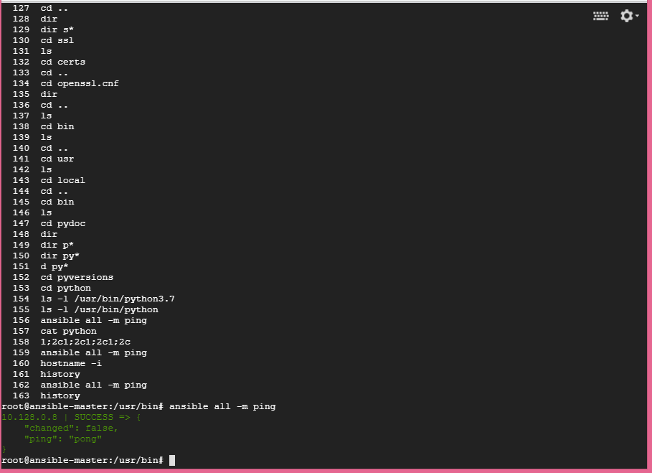

1. Run the playbook.

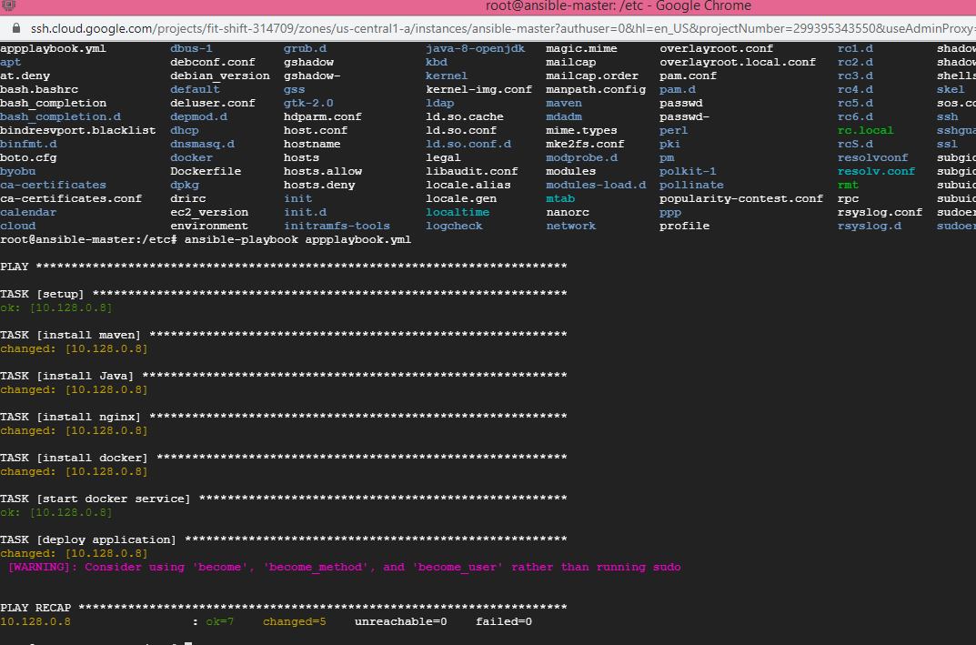

1. Checking the workers node and application.

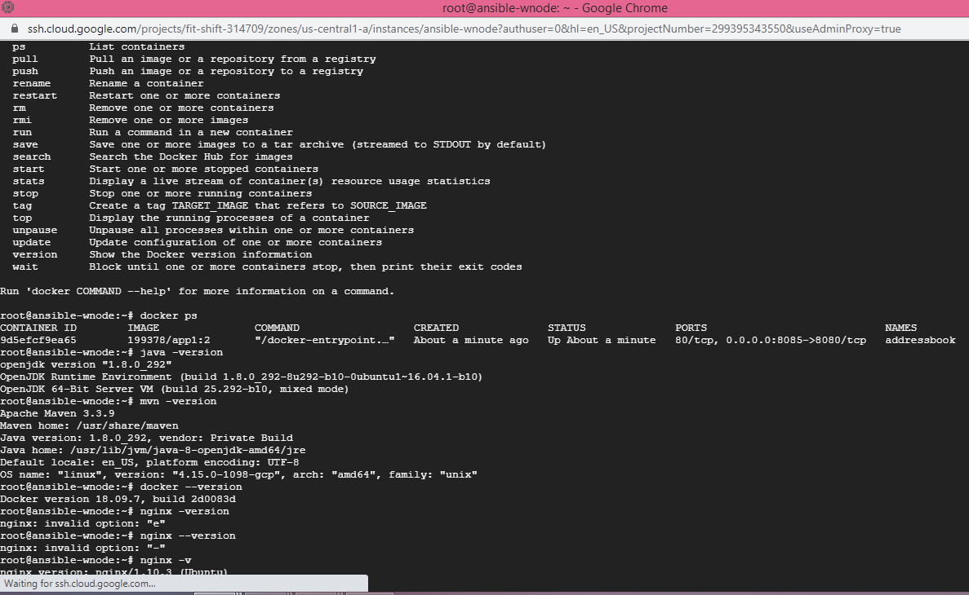

1. Service is up.

